<Date>

**<Customer Name>**

<Designation>

**<Company Name>**

<Address>

**SEWAGE TREATMENT PLANT TECHNICAL PROPOSAL**

Dear **<Name>**:

We are pleased to introduce **Helios Environmental Solutions Incorporated,** a duly-registered corporation & an emerging provider of services that adheres to environmental sustainability.

We havealways been committed to the advocacy of ensuring that future generations may continue to enjoy all of the Earth’s natural resources--thus, creating a better & more sustainable way of life. This commitment also includes providing innovative services, through the delivery of environment-friendly solutions for every Filipino household, community & business, through these key services:

* **Wastewater Solutions**
* **Solar Power Integration**
* **Disinfection Solutions**

With this, we are submitting our Technical Proposal for the design, supply & installation of a _m³/day Sewage Treatment Plant using an Advanced Oxidation Process for your property at <Address>. The proposed Sewage Treatment Plant is designed to accommodate a daily discharge of _m³/day.

Included in this Technical Proposal are the following: Wastewater Treatment Process Flow, Scope of Work, Design Basis, Duration of Work, Warranty, Project Cost & the Terms of Payment for the proposed project.

1. **INTRODUCTION**

**Domestic & Commercial Wastewater**

**Domestic Sewage**

This includes all wastewater generated by home dwellings, public restrooms, hotels, motels, resorts, schools, places of worship, sports stadiums, apartments & the like. Wastewater for commercial and domestic comes in 3 main types, namely: Black Water, Gray Water & Yellow Water.

**Black Water**

This is wastewater that originates from toilet fixtures, dishwashers & food preparation sinks. It is made up of everything going down toilets, bath & sink drains. They include feces, urine, toilet paper & wipes, body cleaning liquids, anal cleansing water, etc. They are known to be highly contaminated with dissolved chemicals, particulate matter & are very pathogenic.

**Gray Water**

This is wastewater that originates from non-toilet & food fixtures such as bathroom sinks, laundry machines, spas, bathtubs, etc. Technically, it is sewage that does not contain feces or urine.

**Yellow Water**

This is basically urine collected with specific channels & not contaminated with either Black Water or Gray Water.

**Helios Environmental Solutions** has developed a system (grease trap/oil separator) that separates the oil before reaching the sewer line. It is easy to maintain, requires no power & is easy to install.

Solidified fats, oil & grease (FOG) shall be treated differently using the Destructive Distillation process.

FOGs are considered lipids that are only soluble to non-polar solvents except water, which is polar in nature. To decompose fats, oil & grease, FOGs must be subjected to the process of molecular dissociation or decomposition through a chemical treatment process before transmitting it into a water-soluble substance ready for digestion (bio-degradation).

1. **PROJECT OBJECTIVE**

To ensure compliance to the pollution prevention requirements of the Department of Environment and Natural Resources (DENR), Laguna Lake Development Authority (LLDA) & the Environmental Management Bureau (EMB), stating that domestic wastewater shall meet or be better than those set under the DENR Class C Inland Waters of DAO 2016-08.

Treatment Advantages:

1. Adheres to DENR DAO 2016 – 08
2. Design flexibility or modular design
3. Small equipment area requirements
4. Low maintenance
5. Easy to operate
6. Minimal sludge production
7. No introduction of enzymes nor bacteria during treatment
8. **DESIGN BASIS**

Flow Rate: _m³/day

Class C inland parameters set by the DENR

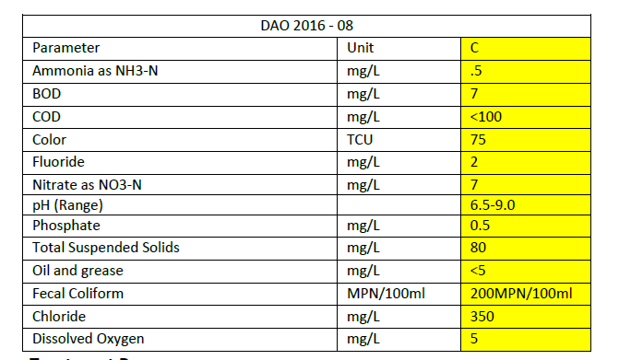

1. **TREATMENT PROCESS**

|  |  |  |
| --- | --- | --- |
|  | **Waste Water** | The influent will be collected in the Sewer Tank |
|  | **Sewer Tank** | * + - 1. Digestive Chamber       2. Anaerobic Digester       3. Lift Station |
|  | **Bar Screen**  **Oil Grease Tank** | Separates solids from water; Separates oil / grease from water |
|  | **Equalization Tank (EQT)** | |  | | --- | | Basins are designed to provide consistent in-fluent flow to downstream processes by retaining high-flow fluctuations. The main function is to act as a buffer. To collect the incoming raw effluent that comes at widely fluctuating rates & position to the rest of the ETP at a steady (Average) flow rate which then overflows to the Pre-Aeration tank | |
|  | **Aeration Tank** | Aeration of wastewater, that is aeration before primary treatment is provided for the following purposes:  1. To obtain a greater removal of suspended solids in sedimentation tanks  2. To assist in the removal of grease and oil carried in the wastewater  3. To freshen up septic wastewater prior to further treatment  4. BOD reduction. Pre-aeration is accomplished by introducing air into the wastewater for a period of 20-30 minutes at the design flow |
| 6. | **Anoxic Tank** | Anoxic means depletion or deficiency of oxygen. Anoxic process is a biological treatment process by which nitrate NO3 nitrogen is converted to molecular nitrogen gas in the absence of oxygen. Anoxic process is also known as denitrification. |
| 7. | **Advanced Oxidation Process** | The influent will now be subjected to the 1st tank of the new STP installed, using a submersible pump. In this stage, the influent undergoes Advanced Oxidation. This is where the air coming from the Air Compressors (a device thatconverts power into potential energy to produce pressurized air) passes through Advanced Oxidation Generators to convert air into O3 & will be distributed to the 1st tank by fine bubble diffusers with a Vortex Tower (The energy of the vortex is a force that improves the quality of water. The swirl effect helps in removing contaminants in the water).  **Advanced Oxidation Generators** - a device that turns regular air into ozone & is capable of removing contaminants in the air & water. It also treats industrial waste.  **Advantages of using Ozone Generators for Water Treatment**  a) Inactivation of viruses  b) Can be used for pesticide removal in water  c) Ozone acts as an effective deodorizer & will eliminate any unpleasant odor from the treated water  d) No re-growth of microorganisms when using ozone disinfection  e) The treatment process does not add chemicals to water  f) Chemical water treatment leaves long-term chemical effects in the environment--some of which are negative, of which, ozone does not  g) Unlike chlorine, ozone leaves no harmful chlorinated by-products in the water; ozone quickly reverts back to pure oxygen if unused  h) Ozone oxidation reactions take place several thousand times faster than those of chlorine & other chemicals in the destruction of bacteria, viruses, yeast, molds, cysts, mildew & most other organic & inorganic contaminants  i) Ozone is generated on-site & does not require storage  j) You cannot overdose with ozone, as unused ozone escapes out of the water & reverts back to oxygen  k) Ozone, in appropriate doses, can treat all water-borne pathogens  l) Ozone oxidizes & destroys oils & other contaminants in the water  m) Ozone acts as a micro-flocculent, aiding in the removal of minerals such as iron & manganese. |
| 8. | **UV Light** | In-fluent will now pass through the UV Lights installed in the 3rd Tank or the Disinfection Tank.  **UV Lights** – electromagnetic radiation with wavelength from 10nanometer to 400nanometer, shorter than visible light but longer than X-rays. It is used to kill or inactivate microorganisms by destroying nucleic acids & disrupting their DNA, leaving them unable to perform vital cellular functions. It produces strong enough UV-C Light in circulating water systems to make them inhospitable to microorganisms such as bacteria, viruses, molds & other pathogens |
| 9. | **Disinfection Tank** | In-fluent will then go through the Disinfection Tank. The diffuser will be installed & Advanced Oxidation Process (AOP) will then take place in this tank for additional decontamination |
| 10. | **Filtration** | Effluent will then be subjected to filtration to remove impurities in the water |
| 11. | **PLC ( Programmable Logic Controller** | The above is controlled by a Programmable Logic Controller (PLC) system & float switches that are positioned at a certain water level |
| 12. | **Discharge** | Three (3) hours per cycle |

**PROCESS FLOW DIAGRAM**

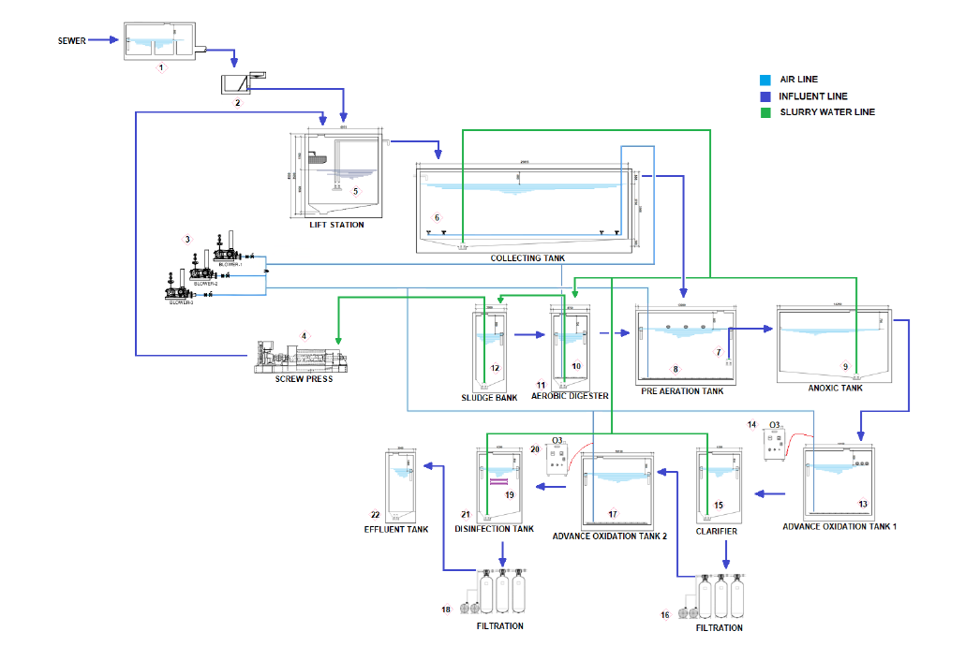

1. **PRICING**
2. **TERMS & CONDITIONS**
3. All quoted prices are exclusive of 12% VAT
4. 50% Down payment
5. 40% Upon completion & turn-over
6. 10% Final Payment upon passing of the water analysis from the DENR/EMB-accredited testing laboratory for the Discharge Permit
7. A Training/Instructional Manual will be issued to your designated Maintenance Operator upon completion of the project
8. Warranty Period for parts & equipment shall be **Twelve (12) Months** from the turn-over date of the operational Sewage Treatment Plant to the end-user
9. An annual maintenance check will be conducted after the expiration of the 12-Month Warranty Period. The Client shall pay Helios Environmental Solutions Incorporated the amount of Ten Thousand Pesos (PHP10,000.00) per annual visit. Spare parts & materials required for the maintenance shall be shouldered by the Client after the Warranty Period.
10. Testing analysis of the treated wastewater with any DENR-accredited laboratory will be as follows:

* First test will be paid for by Helios Environmental Solutions Incorporated
* Succeeding tests will be shouldered by the Client

1. Procurement of the following permits related to the STP construction & operation:

* Initial Discharge Permit from the Laguna Lake Development Authority (LLDA) or;
* Initial Discharge Permit from the Department of Environment & Natural Resources (DENR)

We hope that you would find everything in order. Please do not hesitate to reach out to us through: 0917.863.4895 or 0920.957.0709. You may also email us at: info@helios.ph.

Very truly yours,

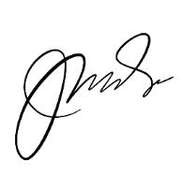

**Jose Mari O. Agregado**

Managing Director

Conforme:

**_____________________________________**

(Please affix your printed name & signature)